NOVASHYLD TECHNOLOGIES
Cybersecurity Analyst Internship Program
Prepared By :- Vikram prajapat
Cybersecurity Analyst Intern
Submission Date: 28-7-2026

Networking, Reconnaissance & Enumeration
Internship Study Guide and Task Documentation

Table of Contents
1. Chapter 1 — Introduction to Networking
2. Chapter 2 — Reconnaissance
3. Chapter 3 — OSINT (Open Source Intelligence)
4. Chapter 4 — Nmap
5. Chapter 5 — Network Scanning
6. Chapter 6 — Service Enumeration
7. Chapter 7 — Operating System Fingerprinting
8. Chapter 8 — Target Profile Documentation
9. Step-by-Step Practical Methodology
10. Deliverables
11. Evaluation Criteria
12. Skills Gained

Chapter 1: Introduction to Networking

1.1 What is Networking?
⇒ Networking is the practice of connecting computers, servers, mobile devices, and other hardware together so that they can exchange data and share resources. A computer network can be as small as two laptops connected in a room, or as vast as the global internet, which links billions of devices across every continent. Networking relies on a shared set of rules, called protocols, which allow devices built by different manufacturers and running different software to communicate in a predictable and reliable way.
⇒ For a Cybersecurity Analyst Intern, networking is the foundation on which every other skill is built. Before an analyst can search for vulnerabilities, detect malicious traffic, or defend an organization's infrastructure, they must first understand how information physically and logically travels between devices. Without this foundation, later topics such as reconnaissance, port scanning, and enumeration would be difficult to understand in any meaningful, practical sense.

1.2 Importance of Networking in Cybersecurity
⇒ Every cybersecurity engagement, whether it is a professional penetration test, an internal vulnerability assessment, or a real-world incident response investigation, begins with the network. Attackers and defenders alike operate within the same technical landscape of IP addresses, ports, and protocols. A cybersecurity analyst who understands networking can:
- Identify how data flows between a client and a server, and where that flow might be intercepted or manipulated.
- Recognize normal traffic patterns so that abnormal or suspicious traffic stands out.
- Understand how firewalls, routers, and switches shape what is reachable from a given vantage point.
- Communicate findings clearly to both technical and non-technical stakeholders using accurate terminology.

⇒ In short, networking knowledge transforms a security tool's raw output into meaningful, actionable intelligence. A scan result showing 'port 445 open' means little without an understanding of what that port represents and why its exposure matters.

1.3 Basic Networking Concepts

1.3.1 IP Addresses
⇒ An IP (Internet Protocol) address is a numerical label assigned to each device on a network, allowing it to be located and communicated with. IPv4 addresses are written as four decimal numbers separated by dots (for example, 57.144.220.34), while the newer IPv6 standard uses a longer hexadecimal format to accommodate the growing number of internet-connected devices.

1.3.2 Ports and Protocols
⇒ A port is a logical endpoint that allows a single IP address to support multiple simultaneous services. Ports are numbered from 0 to 65535, and specific ranges are conventionally reserved for particular services — for example, port 80 for unencrypted web traffic (HTTP) and port 443 for encrypted web traffic (HTTPS). Protocols such as TCP (Transmission Control Protocol) and UDP (User Datagram Protocol) define the rules governing how data is packaged, transmitted, and reassembled between two ports.

1.3.3 The OSI and TCP/IP Models
⇒ The OSI (Open Systems Interconnection) model divides network communication into seven conceptual layers, from the Physical layer (cabling and signals) up to the Application layer (the software the user interacts with). The simplified TCP/IP model, which is more commonly used in practice, condenses these into four layers: Network Interface, Internet, Transport, and Application. Understanding these layers helps an analyst reason about where a particular security control, vulnerability, or piece of evidence exists.

1.3.4 DNS (Domain Name System)
⇒ DNS translates human-readable domain names, such as example.com, into machine-readable IP addresses. It functions as the internet's directory service. Because DNS records often reveal information about an organization's infrastructure, mail servers, and subdomains, they form an important part of the reconnaissance process described in Chapter 2.

1.3.5 Routers, Switches, and Firewalls
⇒ Switches connect devices within a single local network and forward traffic based on hardware (MAC) addresses. Routers connect separate networks together and forward traffic based on IP addresses, commonly serving as the boundary between an internal network and the wider internet. Firewalls inspect and filter traffic according to defined rules, and are one of the first lines of defense an analyst will need to account for when planning a scan.

1.4 Networking in Penetration Testing
⇒ Penetration testing, often abbreviated as pentesting, is the authorized simulation of a cyberattack against a system in order to identify exploitable weaknesses before a malicious actor can find them. Networking knowledge underpins nearly every phase of a penetration test:
- During reconnaissance, the tester maps out which hosts exist and how they are addressed.
- During scanning, the tester determines which ports and services are reachable on those hosts.
- During enumeration, the tester extracts detailed information about the services discovered.
- During reporting, the tester must describe network-level findings in a way that is both technically accurate and understandable to the client.

⇒ This internship task, Networking, Reconnaissance & Enumeration, is designed to build this foundation through hands-on, guided practice using industry-standard tools, all performed strictly within authorized and legal testing environments such as personal lab machines or intentionally vulnerable practice systems.

Chapter 2: Reconnaissance

2.1 What is Reconnaissance?
⇒ Reconnaissance, often shortened to 'recon,' is the first formal phase of a security assessment. It refers to the systematic process of gathering information about a target — whether that target is a single host, a website, or an entire organization — before any direct technical interaction takes place. The goal is to build a clear picture of the target's digital footprint: its domains, infrastructure, personnel, and technologies.

2.2 Objectives of Reconnaissance
- Identify the scope and boundaries of the target environment.
- Discover domains, subdomains, and IP address ranges belonging to the target.
- Understand the organization's technology stack and third-party service providers.
- Reduce the risk of the assessment by learning as much as possible before sending any active traffic.
- Build a foundation of evidence that later phases (scanning and enumeration) can build upon.

2.3 Passive Reconnaissance
⇒ Passive reconnaissance gathers information about a target without directly interacting with its systems. Because no packets are sent to the target's infrastructure, passive techniques are virtually undetectable to the target and carry minimal risk of triggering alerts. Common passive techniques include:
- Searching public search engines for company documents, job postings, and press releases.
- Reviewing WHOIS registration records for domain ownership and registration details.
- Examining publicly available DNS records through third-party lookup services.
- Reviewing social media profiles and professional networking sites for employee and organizational information.
- Studying cached or archived versions of websites.

2.4 Active Reconnaissance
⇒ Active reconnaissance involves direct interaction with the target's systems, such as sending network requests to determine which hosts are alive or which services respond. Because this generates network traffic that a target's monitoring systems may detect, active reconnaissance carries more risk than passive methods and must only ever be performed against systems the analyst is explicitly authorized to test. Common active techniques include:
- Pinging hosts to determine whether they are reachable.
- Performing direct DNS queries against a target's own name servers.
- Running lightweight network scans to identify live hosts within an authorized IP range.

2.5 Importance of Information Gathering
⇒ A thorough reconnaissance phase directly shapes the quality of every phase that follows. An analyst who has correctly mapped a target's subdomains, IP ranges, and technologies will scan more efficiently, interpret enumeration results with better context, and produce a final report that is both accurate and comprehensive. Skipping or rushing this phase is one of the most common reasons that later technical findings appear disorganized or incomplete.

2.6 Real-World Examples
⇒ In real-world engagements, analysts routinely combine WHOIS lookups, DNS enumeration, and search-engine research to build an initial target map before any scanning begins. For example, a WHOIS record might reveal the registrar and administrative contact of a domain, while a review of DNS records might reveal a subdomain such as mail.example.com or vpn.example.com, each pointing to infrastructure worth investigating further during the active phases described in later chapters. This internship task walks through equivalent exercises using safe, authorized lab targets.
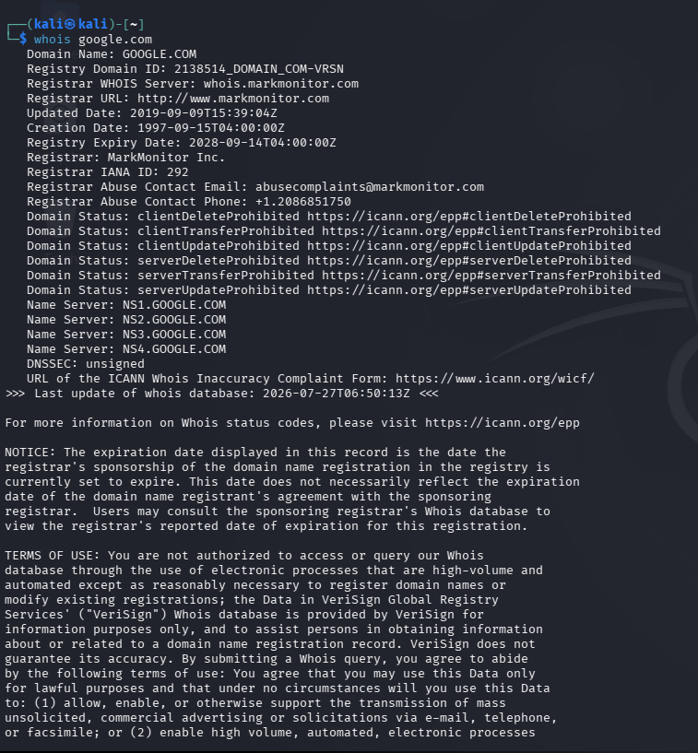
Passive Reconnaissance

Chapter 3: OSINT (Open Source Intelligence)

3.1 What is OSINT?
Open Source Intelligence, commonly abbreviated as OSINT, is the practice of collecting and analyzing information from publicly available sources to produce actionable intelligence. In cybersecurity, OSINT is used to understand a target organization's public-facing footprint before an assessment begins, drawing on sources such as search engines, domain registries, DNS records, social media, and public code repositories.

3.2 Why OSINT is Important
OSINT allows an analyst to gather substantial, useful information entirely from public sources and without touching the target's systems directly. This makes it one of the safest and most cost-effective steps in the entire assessment process. It also helps analysts understand a target's exposure from the perspective of an outside attacker, which is precisely the perspective a defensive security program must account for.

3.3 Domain Information
Domain information includes the registrar, registration and expiration dates, name servers, and (where not redacted by privacy services) administrative and technical contact details associated with a domain name. This is typically obtained through a WHOIS lookup, which is explained in detail with practical steps in the methodology section of this guide.

3.4 DNS Information
DNS information reveals how a domain's name resolves to IP addresses and related infrastructure. Key DNS record types include the A record (maps a hostname to an IPv4 address), AAAA record (maps a hostname to an IPv6 address), MX record (identifies mail servers), NS record (identifies authoritative name servers), TXT record (stores arbitrary text, often used for domain verification or email security policies), and CNAME record (creates an alias from one hostname to another).

3.5 Email Intelligence
Email intelligence involves identifying the format and structure of an organization's email addresses (for example, firstname.lastname@example.com), which can later assist in understanding the organization's naming conventions. Analysts gather this information exclusively from public sources such as company websites, press materials, and professional networking profiles, and must always handle any personal data encountered in strict accordance with applicable privacy laws and the engagement's rules of scope.

3.6 Public Information Sources
- Search engines, using advanced search operators to narrow results to a specific domain.
- Public records and business registries.
- Job postings, which often reveal the specific technologies an organization uses internally.
- Professional networking sites, which can reveal organizational structure and technology stacks listed by employees.
- Certificate transparency logs, which reveal subdomains listed on SSL/TLS certificates issued for a domain.

3.7 Infrastructure Intelligence
Infrastructure intelligence combines the domain and DNS information gathered above to build a picture of the systems an organization operates: which cloud provider or hosting company they use, which IP ranges belong to them, and which third-party services (such as content delivery networks or email providers) are in play. This picture becomes the direct input to the active reconnaissance and scanning phases described in the following chapters.
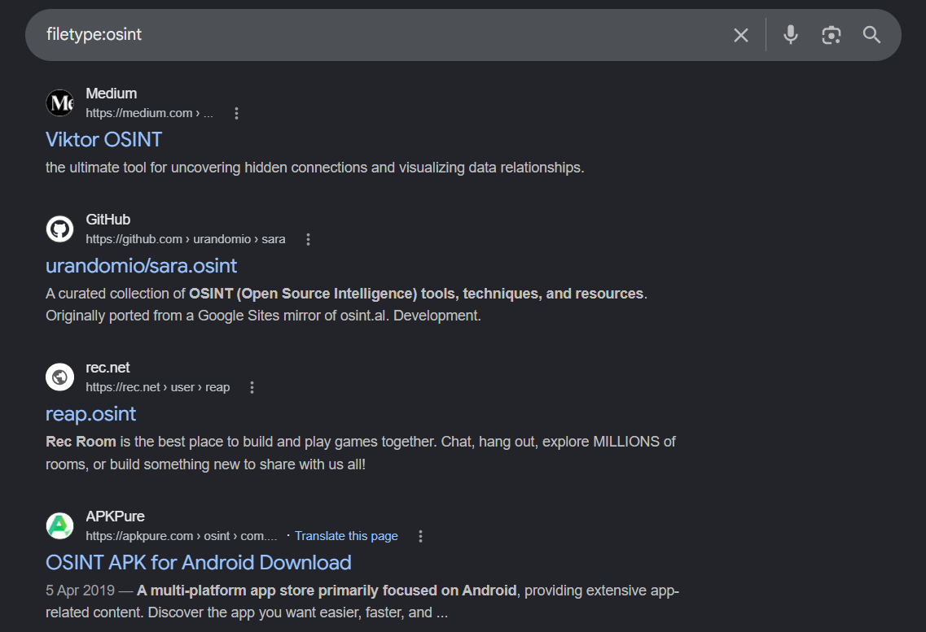
OSINT Research

WHOIS Lookup
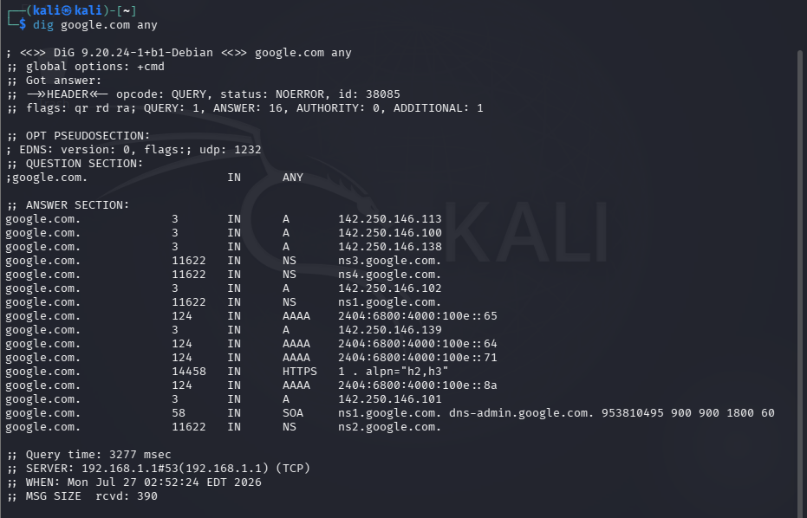
DNS Lookup

Chapter 4: Nmap

4.1 Introduction
Nmap (Network Mapper) is a free and open-source utility used for network discovery and security auditing. First released in 1997, it has become the industry-standard tool for host discovery, port scanning, service detection, and operating system fingerprinting. Nmap is used extensively by network administrators for inventory and maintenance, and by security professionals for authorized vulnerability assessments and penetration tests.

4.2 Features
- Host discovery to identify which systems are online within a given network range.
- Port scanning to determine which TCP and UDP ports are open, closed, or filtered.
- Service and version detection to identify the exact software running behind an open port.
- Operating system fingerprinting to estimate the target's operating system and kernel version.
- A scripting engine (NSE) that automates a wide range of additional discovery and auditing tasks.
- Flexible output formats suitable for both manual review and further automated processing.

4.3 Installation
Nmap is available for Windows, Linux, and macOS, and is pre-installed on most security-focused Linux distributions such as Kali Linux and Parrot OS. On other systems, it can be installed using the appropriate package manager.
# kali / Ubuntu /
sudo apt update && sudo apt install nmap

# Red Hat / CentOS / Fedora
sudo dnf install nmap

# macOS (Homebrew)
brew install nmap
After installation, confirm the version with the following command, which also serves as a quick sanity check that Nmap is correctly installed and reachable on the system's PATH.
nmap --version

4.4 Host Discovery
Before scanning individual ports, it is often useful to identify which hosts within a range are actually online. Nmap's ping scan (-sn) performs host discovery without scanning any ports, making it a fast and low-impact first step.

4.4.1 Ping Scan
Purpose: To quickly identify which hosts in a target range are online, without scanning any ports.
Syntax:
nmap -sn <target-range>

Example:
nmap 192.168.1.29/24

Expected Output:
Nmap scan report for 57.144.220.34
Host is up (0.0021s latency).
Nmap scan report for 57.144.220.34
Host is up (0.0045s latency).
Nmap done: 256 IP addresses (2 hosts up) scanned in 3.14 seconds
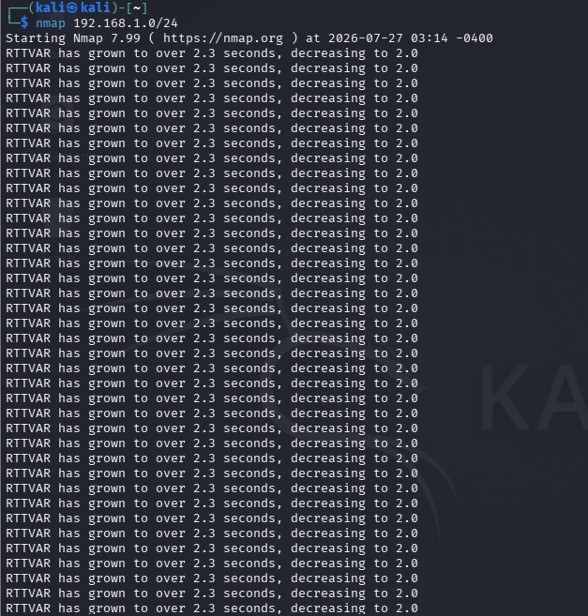

Verification: Cross-check the list of 'up' hosts against known lab devices (for example, the router and the intentionally vulnerable practice VM) to confirm the scan reflects the expected lab topology.

4.5 Port Scanning
Port scanning is the process of probing a target's ports to determine their state: open (a service is actively listening), closed (no service is listening, but the host responded), or filtered (a firewall or filtering device is blocking the probe). The basic Nmap command below performs a default TCP scan of the 1,000 most common ports.

4.5.1 nmap <target>
Purpose: To perform a default scan of the 1,000 most commonly used TCP ports on a target host, revealing which services are exposed.
Syntax:
nmap <target>

Example:
nmap 57.144.220.34

Expected Output:
Starting Nmap ( https://nmap.org )
Nmap scan report for 57.144.220.34
Host is up (0.0032s latency).
PORT STATE SERVICE
22/tcp open ssh
80/tcp open http
445/tcp open microsoft-ds
Nmap done: 1 IP address (1 host up) scanned in 4.87 seconds
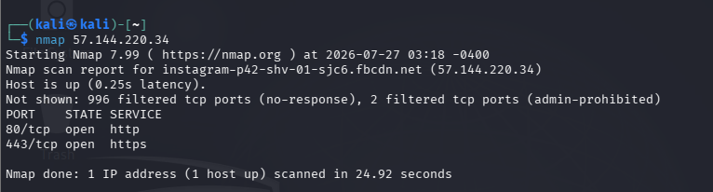

Verification: Confirm each reported open port against the lab environment's known configuration, and record the results in the Nmap Scan Report deliverable described later in this guide.

4.6 Service Detection
Once open ports have been identified, the next step is to determine which specific software is answering on each port. This is more informative than the port number alone, since the same port can theoretically be reassigned to a different service.

4.6.1 nmap -sV <target>
Purpose: To probe open ports and attempt to determine the specific service and version of software running behind each one.
Syntax:
nmap -sV <target>

Example:
nmap -sV 57.144.220.34

Expected Output:
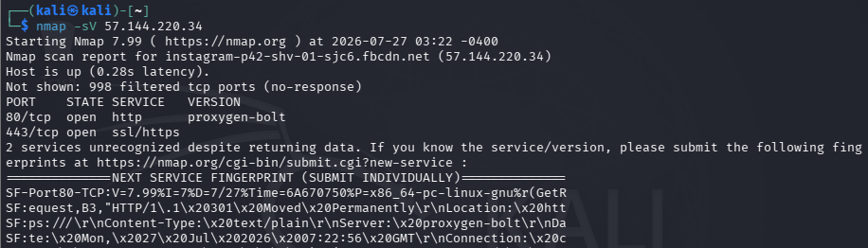

Verification: Compare the detected version strings with the vendor's official release notes to confirm the version reported is plausible for the lab image being used.

4.7 Version Detection (Deeper Probing)
Nmap's version detection engine (invoked with -sV) sends a series of probes defined in its nmap-service-probes database and compares the responses against known signatures. Increasing the intensity level with --version-intensity can reveal additional detail at the cost of a longer scan time, which is useful when the default probes return an ambiguous result.
nmap -sV --version-intensity 57.144.220.34

4.8 Operating System Detection

4.8.1 nmap -O <target>
Purpose: To estimate the target's operating system family and version by analyzing subtle differences in how its TCP/IP stack responds to crafted probes.
Syntax:
nmap -O <target>

Example:
nmap -O 57.144.220.34

Expected Output:
Running: Linux 5.X
OS CPE: cpe:/o:linux:linux_kernel:5
OS details: Linux 5.0 - 5.14
Network Distance: 1 hop

Verification: Because OS fingerprinting is probabilistic, treat the result as an estimate and corroborate it with service banners (for example, an SSH banner that names a specific Linux distribution).

4.9 Combined Aggressive Scan

4.9.1 nmap -A <target>
Purpose: To perform a comprehensive scan in a single command, combining service/version detection, OS detection, script scanning, and a traceroute.
Syntax:
nmap -A <target>

Example:
nmap -A 57.144.220.34

Expected Output:
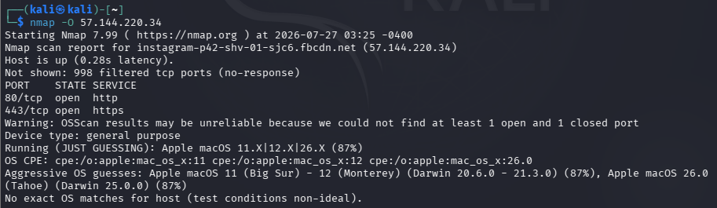

Verification: Because -A is more intrusive and noisier than individual flags, use it only once initial, lighter scans have confirmed the target and scope are correct, and record the full output for the deliverables.

Chapter 5: Network Scanning

5.1 Host Discovery
As introduced in Chapter 4, host discovery is the process of determining which addresses within a network range currently host a live, reachable system. This step prevents the analyst from wasting time and generating unnecessary traffic against addresses that are not in use.

5.2 Live Host Detection
In addition to Nmap's ping scan, live hosts can be identified using ICMP echo requests (the standard 'ping' utility) or ARP requests when operating on the same local network segment. ARP-based discovery is especially reliable on local networks because many hosts are configured to block ICMP but cannot avoid responding to ARP, which is required for basic local communication.
ping -c 4 192.168.1.29
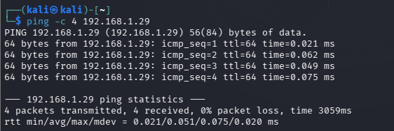

5.3 TCP Scan
A TCP scan interacts with the Transmission Control Protocol's three-way handshake to determine port state. Nmap's default SYN scan (-sS) sends a SYN packet and observes the response: a SYN/ACK indicates an open port, while a RST indicates a closed one. This method is often called a 'half-open' scan because it does not complete the handshake, making it faster and comparatively less conspicuous than a full connect scan.

5.3.1 TCP SYN Scan
Purpose: To efficiently determine the state of TCP ports using a half-open handshake, which is faster and generates less log noise than a full TCP connection.
Syntax:
sudo nmap -sS <target>

Example:
sudo nmap -sS 57.144.220.34

Expected Output:
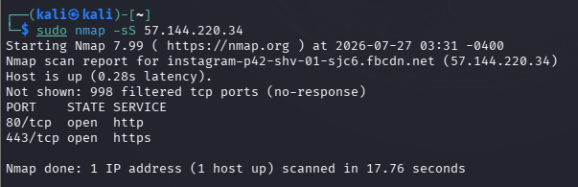

Verification: Compare results with a full TCP connect scan (-sT) if raw socket privileges are unavailable, and note any discrepancy for the enumeration sheet.
5.4 UDP Scan
UDP is a connectionless protocol, which makes scanning it slower and less precise than TCP scanning, since the absence of a response can mean either an open port or a filtered one. Nmap's UDP scan (-sU) sends empty (or protocol-specific) UDP packets and interprets ICMP 'port unreachable' responses as a sign that a port is closed.
sudo nmap -sU --top-ports 20 57.144.220.34

5.5 Port Discovery
Beyond the default 1,000 ports, Nmap can be directed to scan a custom range, a specific list, or the full 65,535-port space, which is recommended whenever time permits during a thorough assessment.
nmap -p 1-65535 57.144.220.34
nmap -p 22,80,443 57.144.220.34

Chapter 6: Service Enumeration

6.1 What is Service Enumeration?
Service enumeration is the process of extracting detailed, actionable information about the services identified during port scanning: their exact software name and version, configuration details, and any banners or metadata they expose. Where port scanning answers the question 'what is open?', enumeration answers the deeper question 'what exactly is running, and what does it reveal?'

6.2 Importance
Detailed enumeration data allows an analyst to research whether a specific software version has any publicly known issues, and provides the concrete detail needed to write a credible, professional report. Vague findings such as 'a web server is running' are far less useful than precise findings such as 'Apache httpd 2.4.52 is running on port 80.'

6.3 Banner Grabbing
Banner grabbing is the technique of connecting to a service and reading the introductory text (the 'banner') it sends, which frequently identifies the software name and version. This can be done manually with a basic TCP client such as Netcat, or automatically through Nmap's version detection.

6.3.1 Manual Banner Grab with Netcat
Purpose: To connect directly to an open port and capture the raw banner text returned by the service.
Syntax:
nc -nv <target> <port>

Example:
nc -nv 57.144.220.34 22

Expected Output:
(UNKNOWN) [57.144.220.34] 22 (ssh) open
SSH-2.0-OpenSSH_8.9p1 Ubuntu-3ubuntu0.4

Verification: Record the exact banner string for the enumeration sheet, and note that some services may be configured to omit or falsify their banner, which should be documented as an observation.

6.4 Version Detection
As covered in Chapter 4, Nmap's -sV flag automates version detection across all open ports in a single command, which is generally more efficient than manual banner grabbing for a full host but should be corroborated with manual checks on any critical or unusual services.

6.5 Software Identification
For web services specifically, further identification can be performed by examining HTTP response headers, default file paths, and page titles, which frequently reveal the underlying content management system, web server software, or application framework.
curl -I http://instagram.com

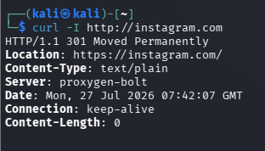

Chapter 7: Operating System Fingerprinting

7.1 What is OS Fingerprinting?
Operating system fingerprinting is the process of identifying a target's operating system family and version by analyzing characteristics of its network behavior. Different operating systems and even different versions of the same operating system implement the TCP/IP stack with subtle variations, and these variations can be measured and compared against a reference database.

7.2 Active Fingerprinting
Active fingerprinting sends specially crafted packets to the target and analyzes the responses, as performed by Nmap's -O flag described in Chapter 4. Because it requires sending traffic directly to the target, it is classified as an active reconnaissance technique and should only be used within an authorized testing scope.

7.3 Passive Fingerprinting
Passive fingerprinting analyzes traffic that the target has already sent, without the analyst needing to send anything themselves. Tools such as p0f examine characteristics like TCP window size and options within captured traffic to estimate the sender's operating system, making this technique useful in monitoring contexts or where active probing would be too intrusive.

7.4 Why OS Detection is Important
Knowing a target's operating system helps an analyst understand which categories of vulnerabilities and default configurations may be relevant, tailor any subsequent authorized testing appropriately, and present a complete, accurate technical profile of the target in the final documentation.

Chapter 8: Target Profile Documentation

8.1 What is Target Profiling?
Target profiling is the process of consolidating every piece of information gathered during reconnaissance, scanning, and enumeration into a single, organized reference document. Rather than leaving findings scattered across scan outputs and notes, the target profile brings them together into one coherent picture of the system under assessment.

8.2 Why It Is Important
A well-built target profile makes it possible for anyone reviewing the assessment — a supervisor, a client, or the analyst's future self — to quickly understand the target's technical composition without re-reading raw scan logs. It also serves as the direct input for risk assessment and reporting.

8.3 Core Elements of a Target Profile
- Host Information: a general description of the target system and its role.
- IP Address: the numeric address(es) associated with the target.
- Domain: any associated domain name(s), if applicable.
- Open Ports: every port found to be open during scanning.
- Running Services: the specific software and version behind each open port.
- Operating System: the estimated OS family and version.
- Technologies: frameworks, content management systems, or platforms identified.
- Attack Surface: a summary of the exposed points that could be relevant to further authorized testing.

8.4 Documentation Process
The target profile should be built incrementally as each phase of the assessment is completed, rather than reconstructed from memory afterward. This internship task requires the intern to complete a structured Target Profile Documentation template, provided later in the Deliverables section, using the data collected during the practical methodology steps.
Step-by-Step Practical Methodology
This section walks through the complete practical workflow the intern will follow, from initial passive research through to a finished target profile. Every step should be performed only against systems the intern owns or is explicitly authorized to test, such as a personal home lab or a purpose-built vulnerable practice machine.

Step 1 — Perform Passive Reconnaissance
Objective: To gather as much information as possible about the lab target using only public, non-intrusive sources, before any direct interaction occurs.
Why this step is required: Passive reconnaissance establishes context and reduces the risk of the assessment, and mirrors the very first phase a real-world engagement would follow.
Exact Procedure:
- Identify the domain name (if any) associated with the lab target.
- Perform a WHOIS lookup on the domain to record registrar and registration details.
- Perform a DNS lookup to record A, MX, NS, and TXT records.
- Search for any publicly available information about the lab environment's technology stack.
whois example.com

dig example.com ANY

nslookup -type=MX example.com
Expected Result: A short written summary listing the domain's registrar, name servers, key DNS records, and any additional public information discovered, with accompanying screenshots.

Step 2 — Perform Active Reconnaissance
Objective: To confirm which hosts within the authorized lab range are online and reachable.
Exact Procedure: Use a ping sweep or Nmap's host-discovery mode across the authorized IP range to build a list of live hosts.
Commands Used:
nmap -sn 192.168.1.0/24
Expected Result: A confirmed list of live IP addresses within the lab network, ready to be scanned in the next step.

Step 3 — Run Nmap Scan
Run each of the following scans against the confirmed lab target, in order, recording the full console output of each: a default scan (nmap <target>), a version detection scan (nmap -sV <target>), an OS detection scan (nmap -O <target>), and finally the combined aggressive scan (nmap -A <target>). Each command, and the reasoning behind it, is explained individually in Chapter 4 of this guide.

Step 4 — Perform Service Enumeration
Procedure: For every open port identified in Step 3, confirm the service name and version, and where appropriate capture the raw service banner using Netcat or curl, as described in Chapter 6.
Commands: nc -nv <target> <port>; curl -I http://<target>
Verification: Cross-check the banner text and Nmap's -sV output against each other; where they disagree, note the discrepancy as an observation in the enumeration sheet.

Step 5 — Perform Operating System Detection
Procedure: Run Nmap's OS detection (-O) and, where available, corroborate the result using service banners that mention a specific distribution or OS build, as described in Chapter 7.
Commands: nmap -O <target>
Verification: Note the confidence level Nmap reports for its OS guess, and treat any single data point as provisional until confirmed by a second source of evidence.

Step 6 — Build Target Profile
Documentation: Consolidate every finding from Steps 1 through 5 into the Target Profile Documentation template provided in the Deliverables section.
Observations: Record any anomalies, unexpected open ports, outdated software versions, or other points worth flagging.
Final Report: Assemble the Nmap Scan Report, the Network & Service Enumeration Sheet, and the Target Profile Documentation into the final internship submission package.

Deliverables
This internship task produces three formal deliverables. Each is described below, along with a ready-to-use template table that should be completed with data gathered during the practical methodology.

1. Nmap Scan Report
What is an Nmap Scan Report? A structured record of every Nmap scan performed against the authorized lab target, including the exact command used, the raw results, and the analyst's observations.
Purpose: To provide a verifiable, repeatable record of the scanning phase that can be reviewed by a supervisor or referenced during later phases of the assessment.
The report should record: Host Discovery Results, Open Ports, Running Services, Service Versions, Operating System Detection, the exact Scan Commands Used, the Date & Time of each scan, and any Observations worth noting.
Field | Recorded Value
Target IP / Host | 57.144.220.34
Scan Date & Time | DD/MM/YYYY, HH:MM
Command Used | nmap -A 57.144.220.34
Host Status | Up
Open Ports | 22, 80, 445
Running Services | OpenSSH 8.9p1, Apache 2.4.52, Samba 4.15.13
Operating System (Estimated) | Linux 5.X
Observations | e.g., outdated software version, unnecessary exposed service

2. Network & Service Enumeration Sheet
Purpose: To provide a granular, per-service breakdown of every port and service discovered on the target, supporting deeper analysis than the summary-level scan report alone.
The sheet should record: IP Address, Hostname, Open Ports, Protocol, Running Services, Service Version, Banner Information, Risk Observation, and Notes.
IP Address | Port | Protocol | Service | Version | Banner | Risk Observation
57.144.220.34 | 22 | TCP | SSH | OpenSSH 8.9p1 | SSH-2.0-OpenSSH_8.9p1 | Low — kept current
57.144.220.34 | 80 | TCP | HTTP | Apache 2.4.52 | Apache/2.4.52 (Ubuntu) | Medium — review headers
57.144.220.34 | 445 | TCP | SMB | Samba 4.15.13 | N/A | Medium — review share permissions

3. Target Profile Documentation
Purpose: To present a single, consolidated technical summary of the target, combining the results of reconnaissance, scanning, and enumeration into a client-ready overview.
Field | Details
Domain | example.local (if applicable)
IP Address | 57.144.220.34
Operating System | Linux 5.X (estimated)
Open Ports | 22, 80, 445
Running Services | OpenSSH, Apache HTTPD, Samba
Technologies | Ubuntu Server, Apache default page
Attack Surface | SSH management interface, public web server, SMB file sharing
Security Observations | e.g., default web page not replaced; verify SMB share permissions
Overall Risk | Low / Medium / High (analyst's assessment)

Evaluation Criteria
Completed submissions for this internship task will be assessed against the following three criteria.

1. Thoroughness of Reconnaissance
⇒ Completeness of Information Gathering: Were all relevant public sources checked, and was the resulting summary complete?
⇒ Quality of Passive Reconnaissance: Was information gathered without any direct interaction with the target, and was it accurately recorded?
⇒ Quality of Active Reconnaissance: Was host discovery performed correctly and safely within the authorized scope?
⇒ Documentation Quality: Is the reconnaissance write-up clear, well-organized, and supported by evidence such as screenshots?

2. Accurate Service & OS Enumeration
⇒ Service Identification: Were all open ports correctly mapped to the services running on them?
⇒ Version Detection: Were software versions accurately recorded and cross-checked where possible?
⇒ Operating System Detection: Was the OS estimate reasonable and corroborated with supporting evidence?
⇒ Verification: Did the intern cross-check automated tool output against a second source, such as a manual banner grab?
⇒ Documentation: Is the enumeration sheet complete, consistent, and free of contradictions?

3. Well-Organized Target Profile Report
⇒ Professional Formatting: Does the report use clear headings, consistent tables, and a professional tone throughout?
⇒ Logical Structure: Does the report follow a sensible order, from general findings to specific detail?
⇒ Clear Findings: Are conclusions stated plainly, with supporting evidence readily identifiable?
⇒ Easy Readability: Could a supervisor unfamiliar with the raw scan data understand the target's profile from the report alone?
⇒ Accurate Documentation: Does every reported detail match the underlying scan and enumeration data?

Skills Gained

1. Network Scanning
⇒ Definition: Network scanning is the technical practice of probing systems to identify live hosts, open ports, and the services running on them.
⇒ Importance: It is the foundation of nearly every subsequent security activity, from vulnerability assessment to incident response.
⇒ Practical Applications: Through this internship task, the intern has gained hands-on experience running host-discovery, TCP, and UDP scans using Nmap, and interpreting their output accurately.

2. OSINT
⇒ Definition: Open Source Intelligence is the discipline of collecting and analyzing publicly available information to build a picture of a target's digital footprint.
⇒ Importance: It allows analysts to understand an organization's external exposure safely, without any direct interaction with its systems.
⇒ Information Gathering: The intern has practiced WHOIS and DNS lookups, and researching public sources for organizational and technical detail.
⇒ Practical Applications: These skills translate directly into the reconnaissance phase of any professional, authorized security assessment.

3. Service Enumeration
⇒ Definition: Service enumeration is the process of extracting detailed information about the specific software and configuration behind each open network port.
⇒ Importance: Detailed, accurate enumeration data is what separates a superficial scan from a genuinely useful security assessment.
⇒ Version Detection: The intern has practiced using Nmap's version detection engine to identify exact software versions.
⇒ Banner Grabbing: The intern has practiced manually connecting to services with tools such as Netcat and curl to confirm automated findings.
⇒ Practical Applications: Together, these skills allow the intern to move from a simple list of open ports to a fully documented, professional target profile suitable for client-facing reporting.

